Exp. 7: Iterative Circuits – Adders and Subtractors

Engineering 357 - Digital Design Lab

Fall 2015

Farnam Adelkhani

Date Experiment Performed: 10-1-2015

Date Report Submitted: 10-2-2015

Farnam Adelkhani

Engineering 357 - Digital Design Lab – 10/1/15

Experiment #7

Exp. 7: Iterative Circuits – Adders and Subtractors

**Abstract and Objective:**

This lab is an introduction to adders and subractors in circuit logic design and more specifically how to implement and test them with Xilinx software. The lab also introduces iterative circuits and its related design techniques. Typical word lengths are in the powers of 2 and so one typically needs to design the circuit for one bit and then imply interconnect multiple copies of that same adder circuit to form a complete circuit for the word, this approach is known as iterative design. Of course, making copies of a circuit is easy when CAD software is being utilized, the experimenter will utilize it to chain several full adders together in order to create a ripple-carry adder.

This lab is also about the design of basic binary add and/or subtract circuits. An adder/subtractor circuit can be implemented from an adder circuit by the inclusion of an add/sub control signal and a XOR gate (1s complementer). Inputs will be used that can be easily verified mathematically to confirm that the circuit is functioning as intended.

**Components Used:**

* Xilinx software on PC
* The following gates/integrated circuits:
* 3 - nand2 quad 2-input NAND
* 3 – XOR2 quad XOR
* Other components as needed

**Procedures and result:**

1. The first step is to complete the pre-lab assignment before the lab class. The prelab assignment in this case required the experimenters to design a full adder circuit using as few logic gates as possible. The circuit that was designed is shown on the next page…

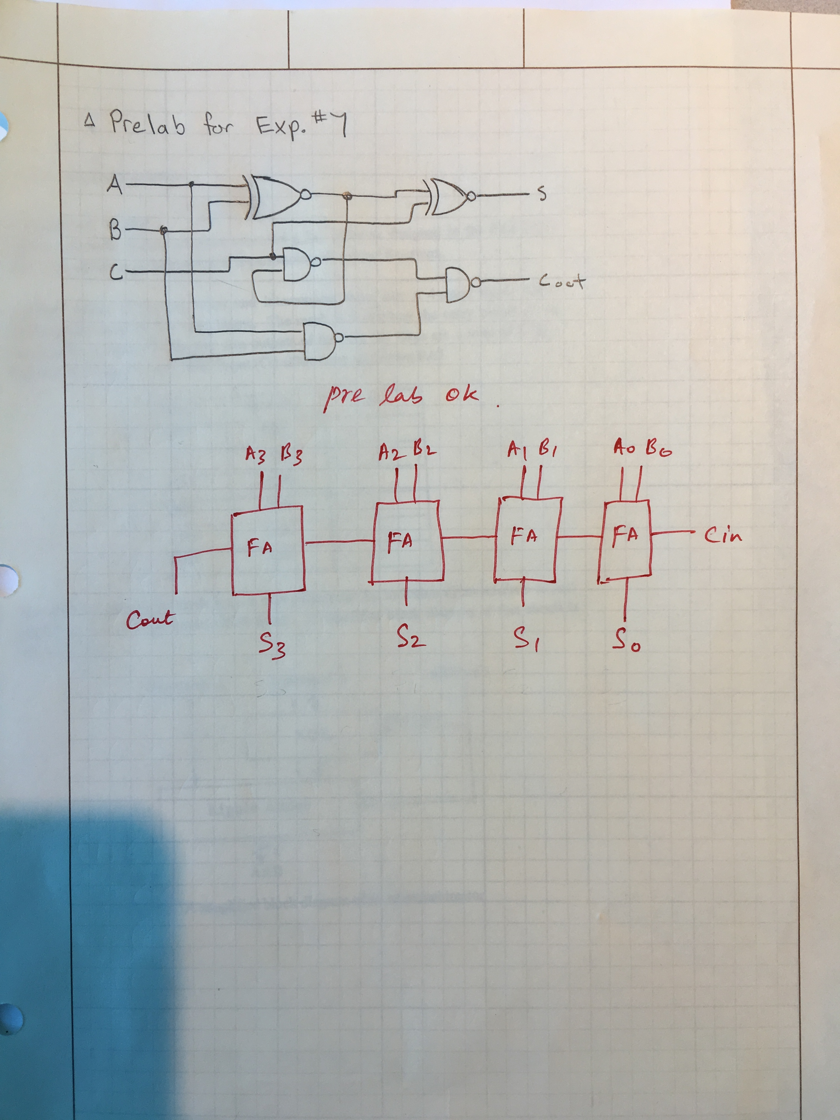

Our full adder was approved (see arrow above).

1. Next step is to construct and implement the full adder circuit that has been designed during the prelab, in Xilinx. Which just requires creating a project and placing the components and wires on the given area. Our adder circuit in Xilinx is pictured below:

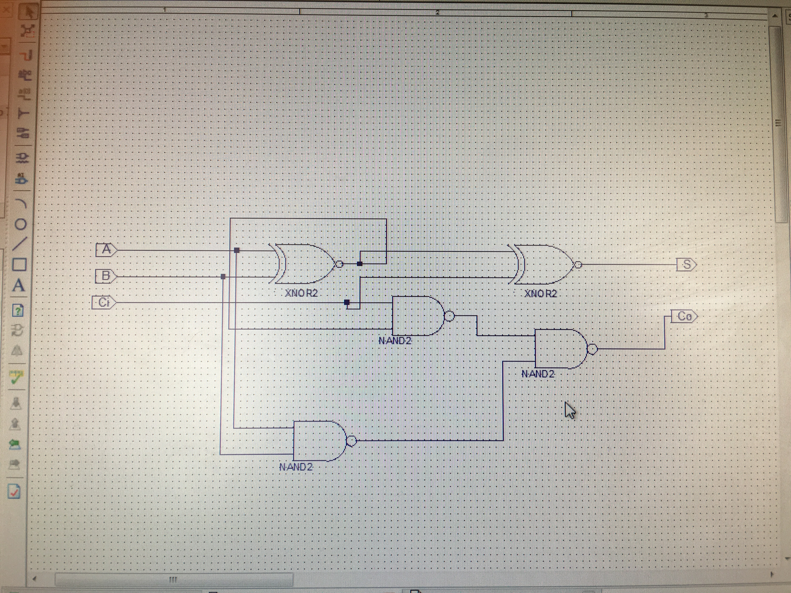

The above circuit was simulated and found to be functional.

1. The next step in this lab is to make four copies of the full adder and interconnect them into a 4-stage ripple adder. The experimenters will test the ripple adder by experimentally completing a table where the inputs can easily be used to confirm the given output in Xilinx is correct. The multi stage ripple adder is shown on the next page in Xilinx:

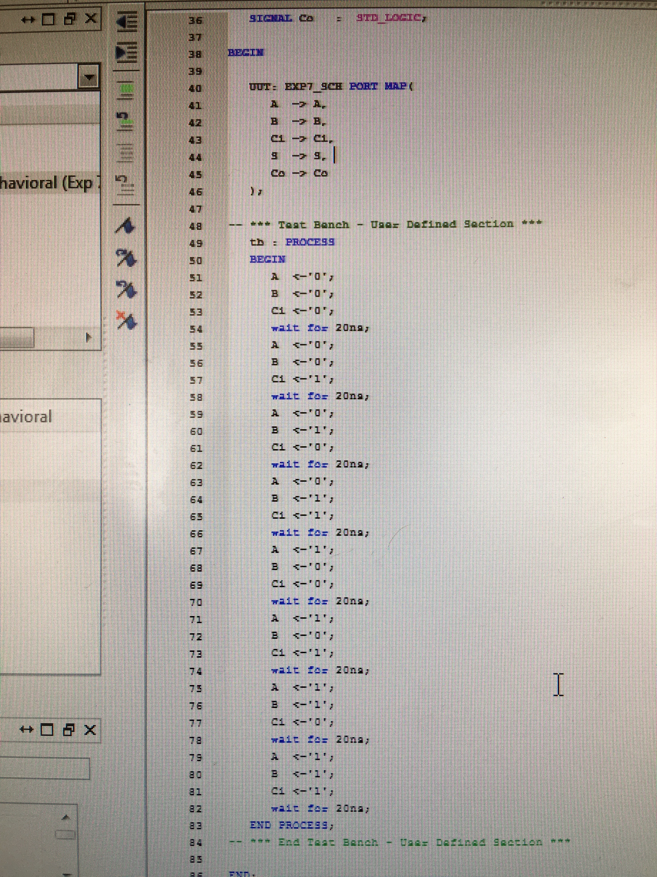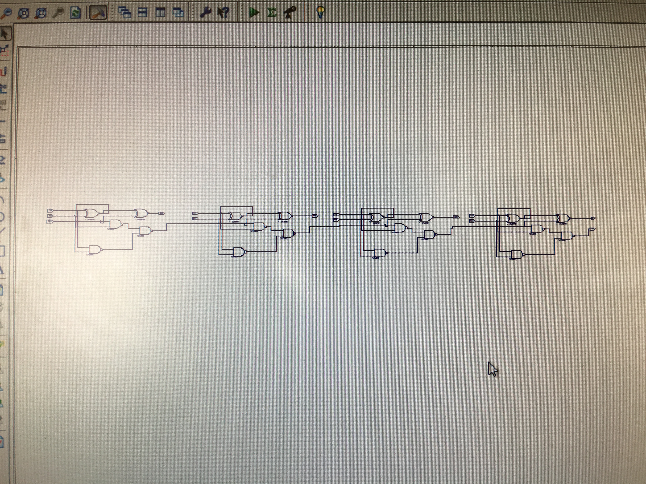

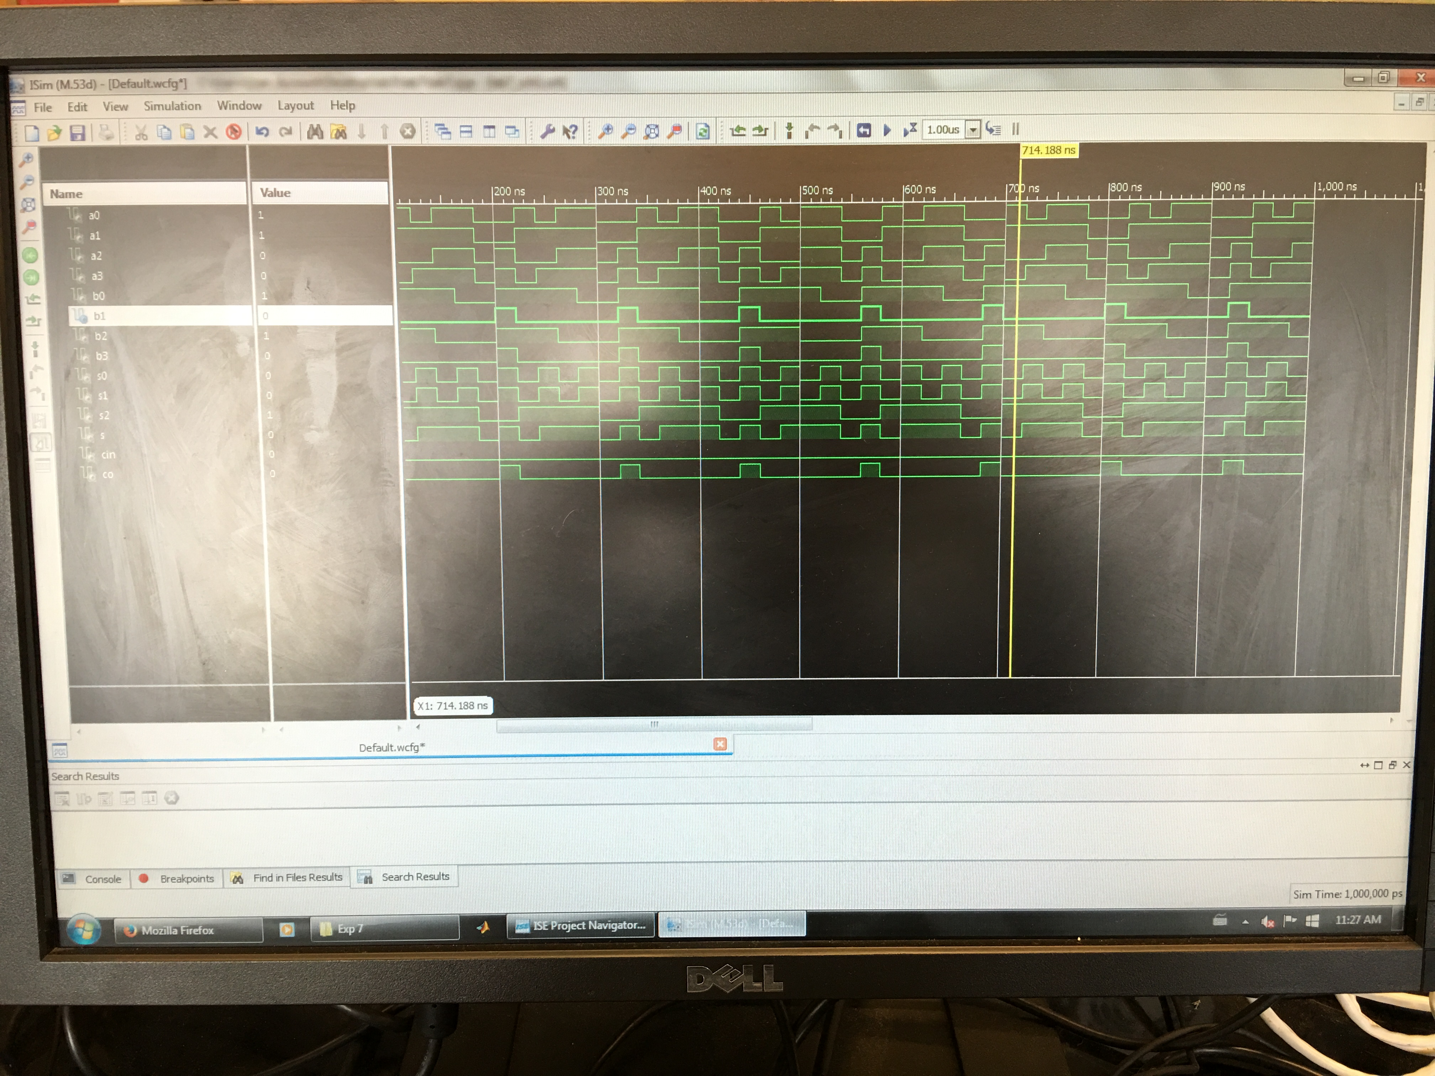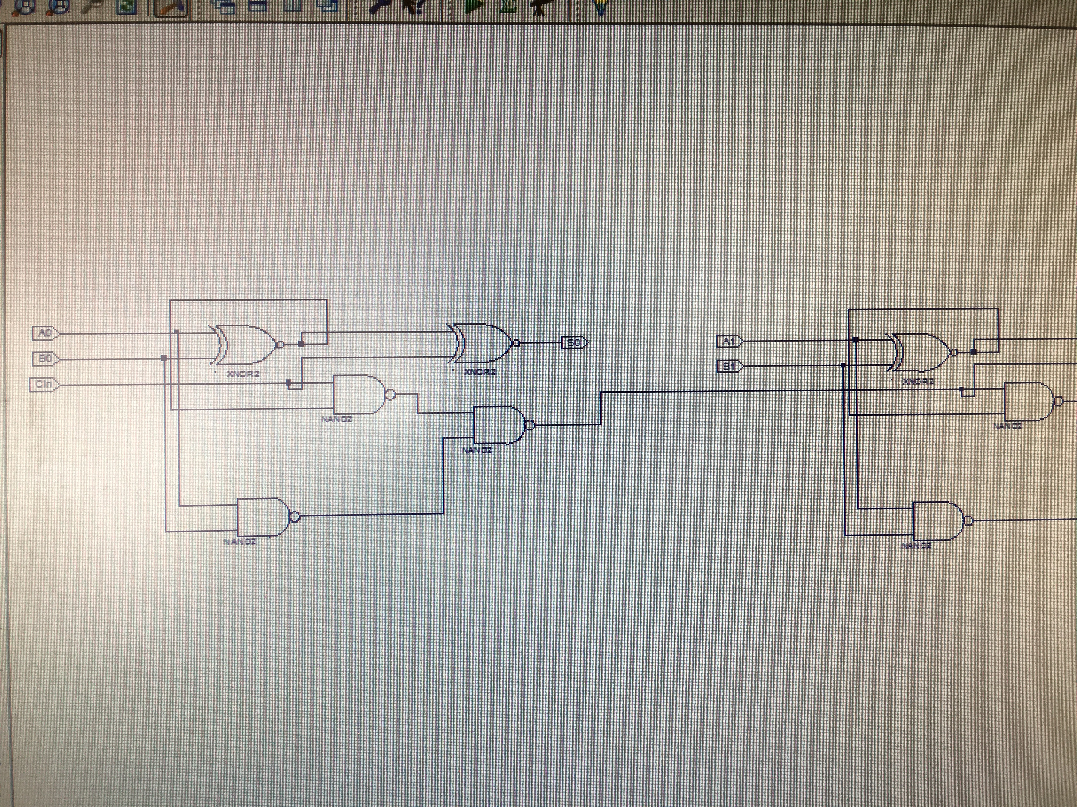

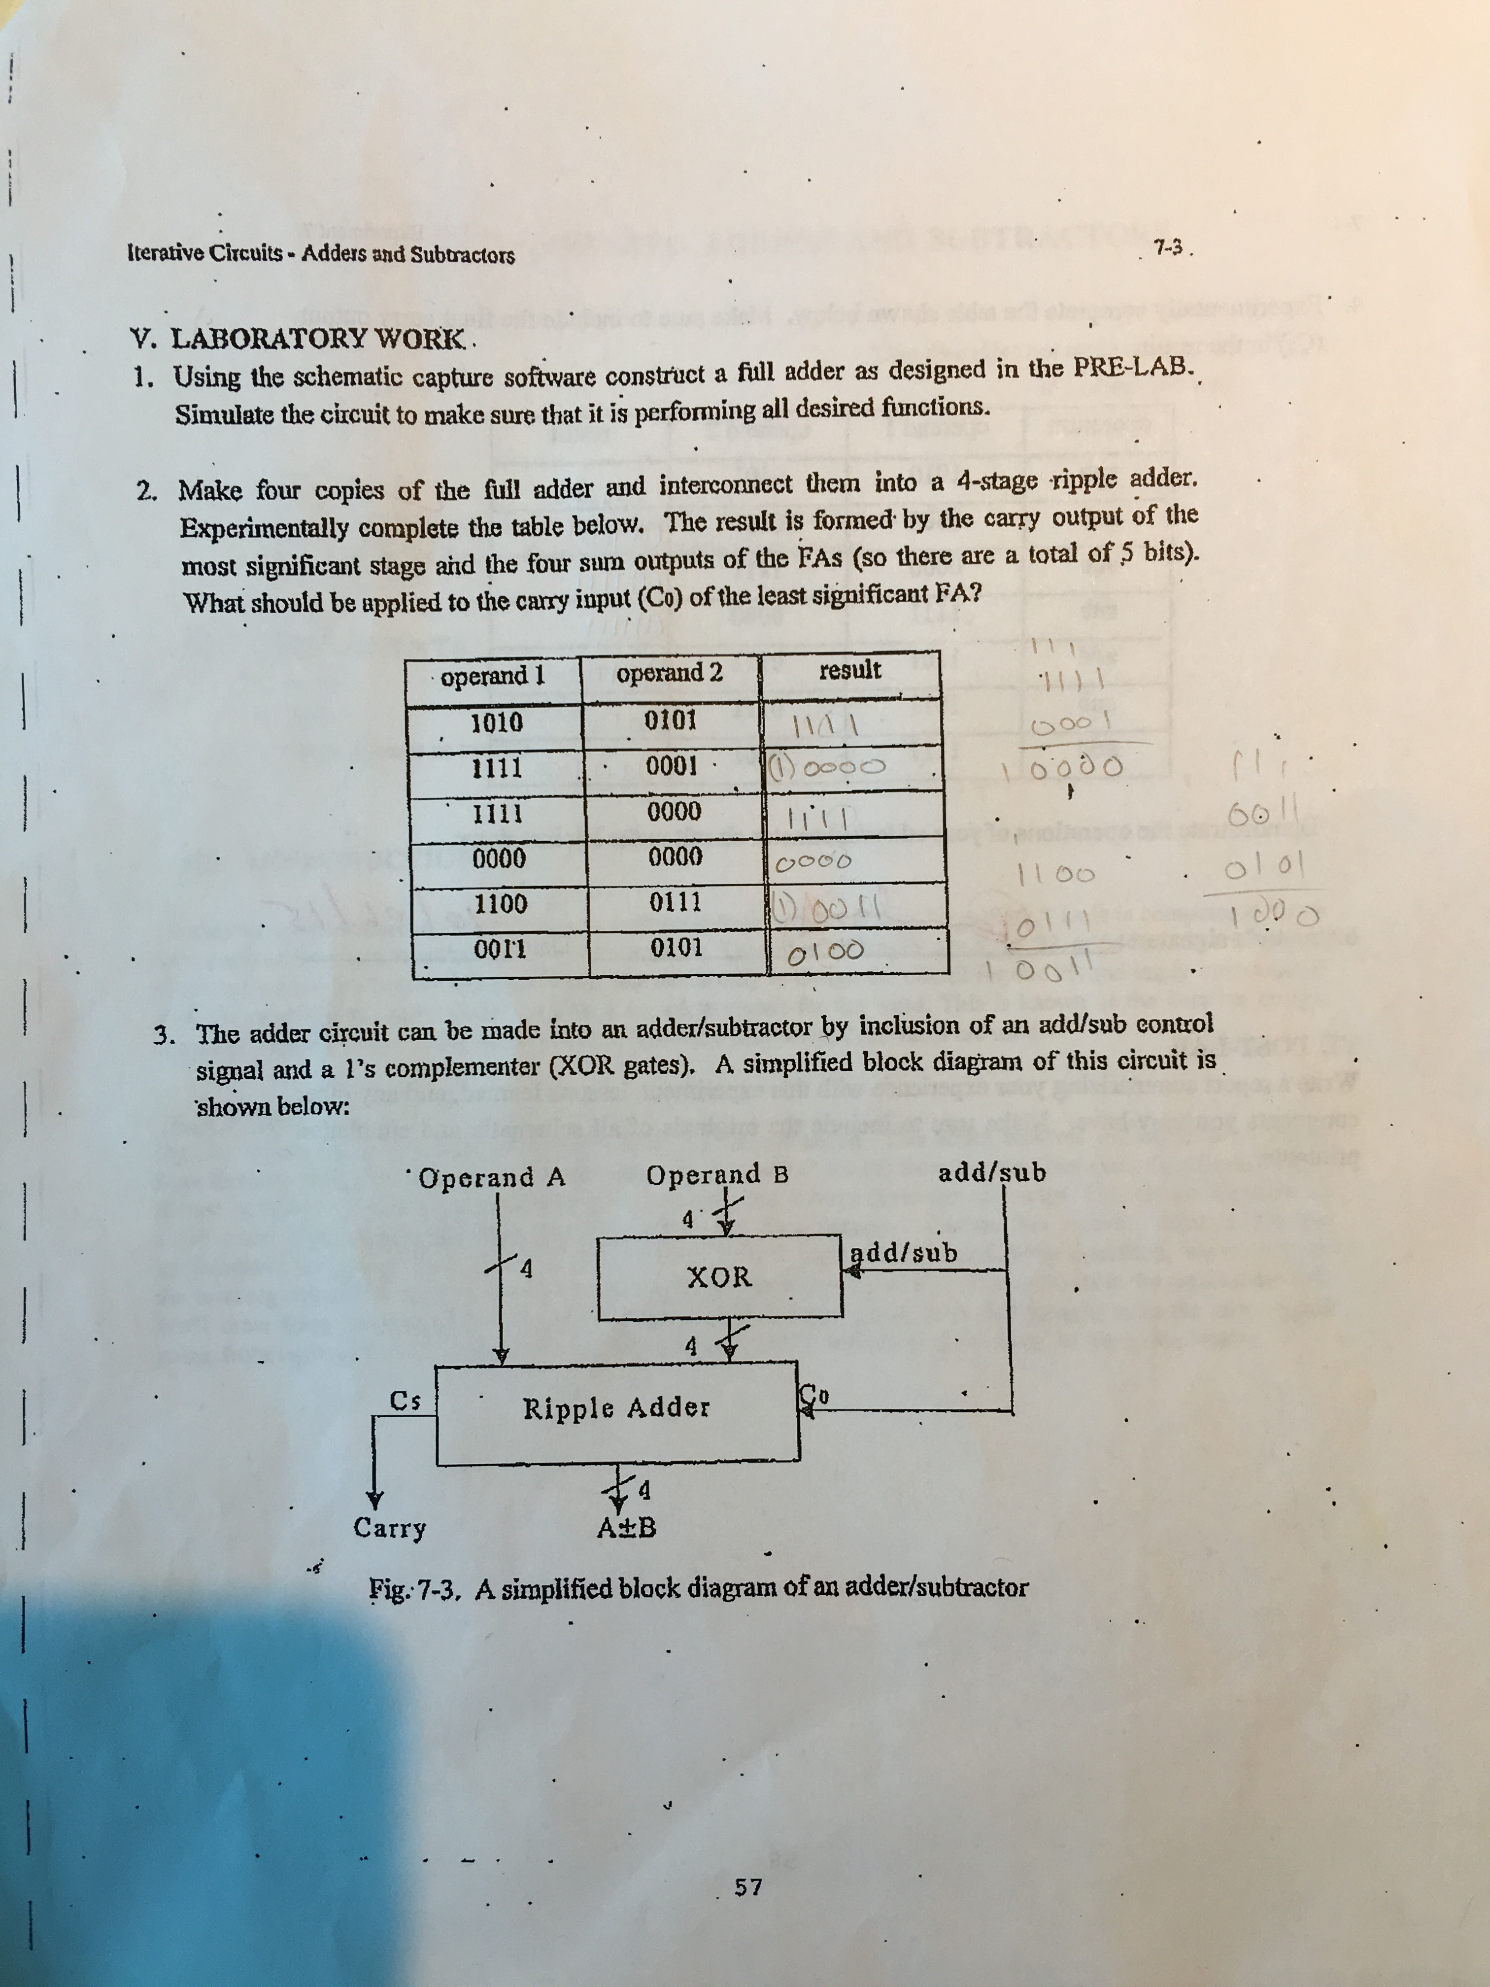

1. The adder circuit can also be made into an adder/subtractor by inclusion of an add/sub control signal and a XOR gate. This circuit was designed and then implementing using the full adder ripple schematics that had already been drawn up. The user implements an XOR gate at each B input with only the first carry bit also feeding into the XOR gate. Every gate thereafter will have the same original carry in value while using the next series of B values. The diagram designed is shown below:

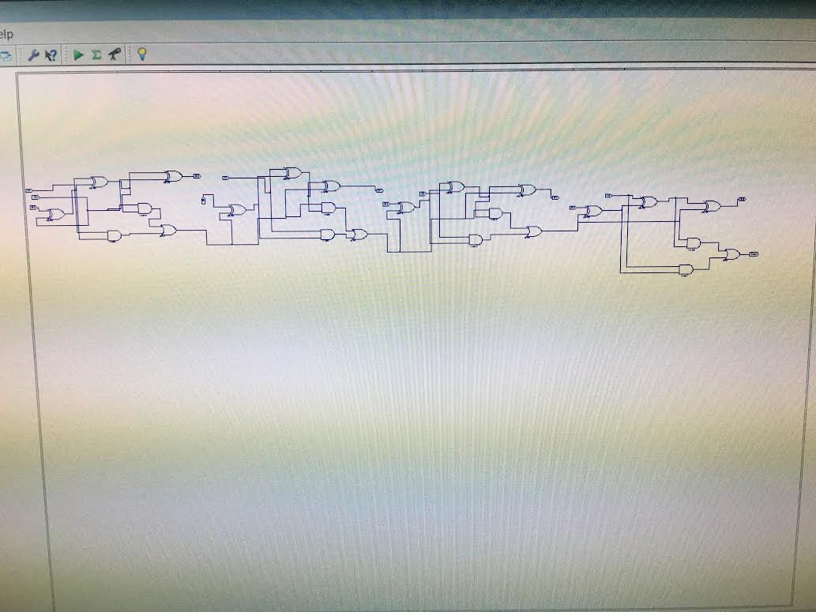

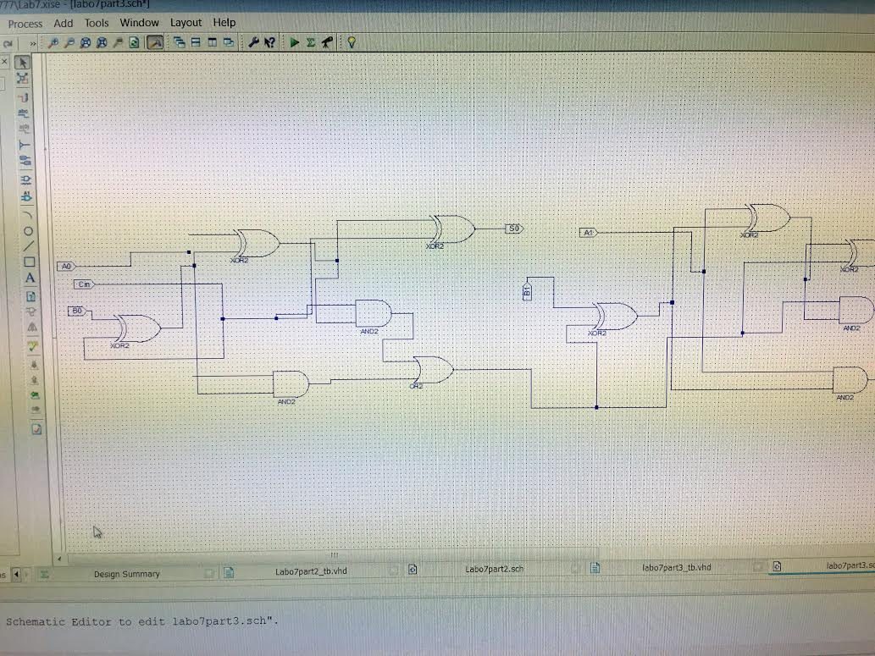



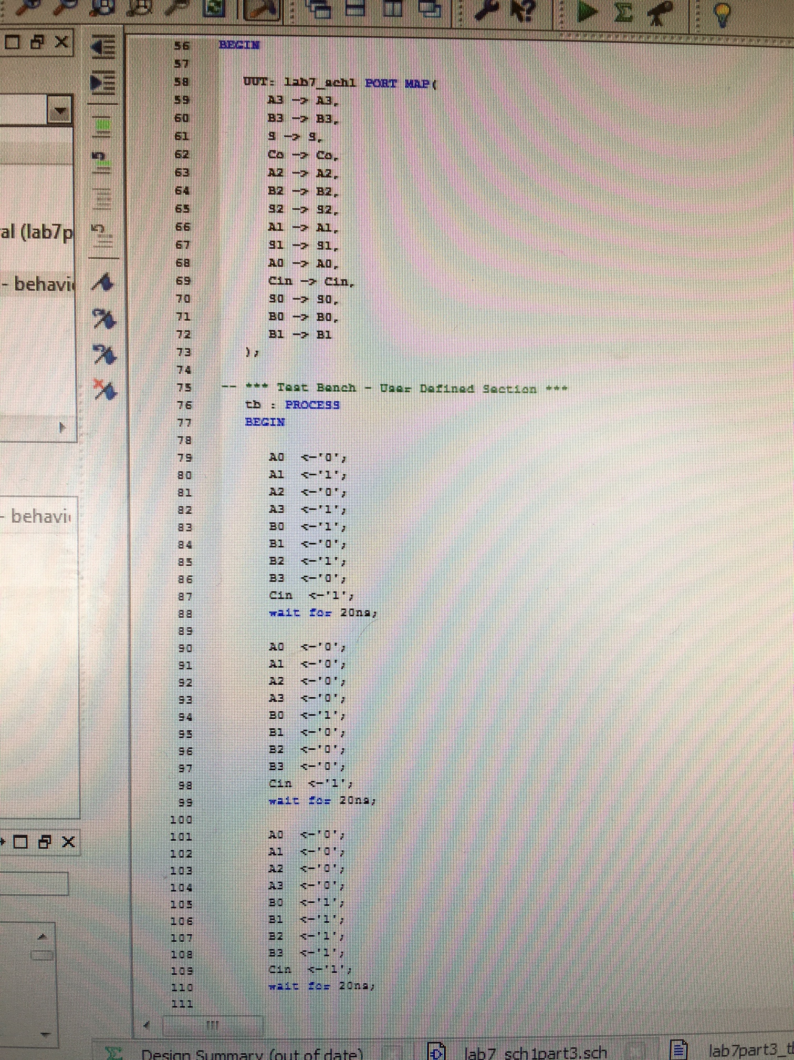

**Conclusion and Summary:**

Now the experimenters have gained familiarity with adder circuit and ripple circuit design while also learning to implement our circuit to perform as an adder/subtractor. It is useful to be given data points that can be confirmed by hand in order to confirm our system is working as expected. There are often issues that arise in the Xilinx software itself. You might assume a 10 gb program is free of bugs but not so by any means. Often the best fix is to save the circuit and reload it. I do have some concern that these software issues with Xilinx may become overbearing as a problem once the circuit is much more complex. It is important and vital that the user are gaining familiarity with the Xilinx design suite.